**1. Create an Android Application Which reads the person, greet message from one activity and**

**display the Greet message on another activity on click of Button (Use Intent)**

**Xml code**

*<?*xml version="1.0" encoding="utf-8"*?>*<RelativeLayout xmlns:android="http://schemas.android.com/apk/res/android"  
 xmlns:app="http://schemas.android.com/apk/res-auto"  
 xmlns:tools="http://schemas.android.com/tools"  
 android:layout_width="match_parent"  
 android:layout_height="match_parent"  
 tools:context=".MainActivity"  
 android:background="#FF69B4">  
 <TextView  
 android:id="@+id/t1"  
 android:layout_width="wrap_content"  
 android:layout_height="wrap_content"  
 android:layout_marginLeft="20dp"  
 android:layout_marginTop="50dp"  
 android:text="Name:"  
 android:textSize="20sp" />  
 <EditText  
 android:layout_width="300dp"  
 android:layout_height="wrap_content"  
 android:layout_alignParentRight="true"  
 android:id="@+id/e1"  
 android:layout_marginTop="38dp"  
 android:layout_marginRight="20dp"  
 android:layout_marginLeft="2dp"/>  
 <Button  
 android:layout_width="100dp"  
 android:layout_height="wrap_content"  
 android:layout_marginTop="125dp"  
 android:layout_marginLeft="150dp"  
 android:id="@+id/b1"  
 android:text="Greet"  
 android:textSize="15sp"/>  
</RelativeLayout>

**Java code**

package com.example.greetmessage;  
  
import androidx.appcompat.app.AppCompatActivity;  
  
import android.content.Intent;  
import android.os.Bundle;  
import android.widget.Button;  
import android.widget.EditText;  
  
  
public class MainActivity extends AppCompatActivity {  
 Button submit;  
 EditText text;  
  
  
 @Override  
 protected void onCreate(Bundle savedInstanceState) {  
 super.onCreate(savedInstanceState);  
 setContentView(R.layout.*activity_main*);  
 submit=findViewById(R.id.*b1*);  
 text=findViewById(R.id.*e1*);  
 submit.setOnClickListener((view -> {  
 String str=text.getText().toString();  
 Intent intent=new Intent(getApplicationContext(),second_activity.class);  
 intent.putExtra("message_key",str);  
 startActivity(intent);  
 }));  
 }  
}

**xml code2**

*<?*xml version="1.0" encoding="utf-8"*?>*<RelativeLayout xmlns:android="http://schemas.android.com/apk/res/android"  
 xmlns:app="http://schemas.android.com/apk/res-auto"  
 xmlns:tools="http://schemas.android.com/tools"  
 android:layout_width="match_parent"  
 android:layout_height="match_parent"  
 tools:context=".second_activity"  
 android:background="#FF69B4">  
 <TextView  
 android:layout_width="300dp"  
 android:layout_height="50dp"  
 android:id="@+id/t2"  
 android:layout_marginTop="50dp"  
 android:layout_marginLeft="50dp"  
 android:textSize="40sp"  
 android:textStyle="italic"  
 android:layout_marginStart="40dp"  
 android:text="Good Morning"  
 android:textColor="@color/black"/>  
 <TextView  
 android:layout_width="300dp"  
 android:layout_height="50dp"  
 android:id="@+id/t3"  
 android:layout_marginTop="15dp"  
 android:layout_marginLeft="50dp"  
 android:textSize="40sp"  
 android:textStyle="italic"  
 android:layout_marginStart="40dp"  
 android:layout_below="@id/t2"  
 android:textColor="@color/black"/>  
</RelativeLayout>

**Java code2**

package com.example.greetmessage;  
  
import androidx.appcompat.app.AppCompatActivity;  
  
import android.content.Intent;  
import android.os.Bundle;  
import android.widget.TextView;  
  
  
public class second_activity extends AppCompatActivity {  
 TextView receiver_message;  
 @Override  
 protected void onCreate(Bundle savedInstanceState) {  
 super.onCreate(savedInstanceState);  
 setContentView(R.layout.*activity_second*);  
 receiver_message=findViewById(R.id.*t3*);  
 Intent intent=getIntent();  
 String str=intent.getStringExtra("message_key");  
 receiver_message.setText(str);  
 }  
}

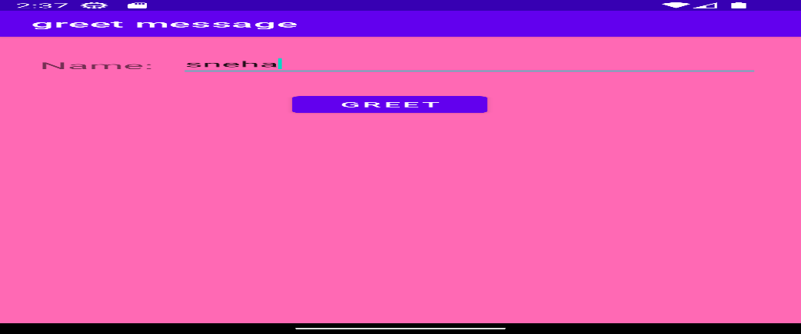

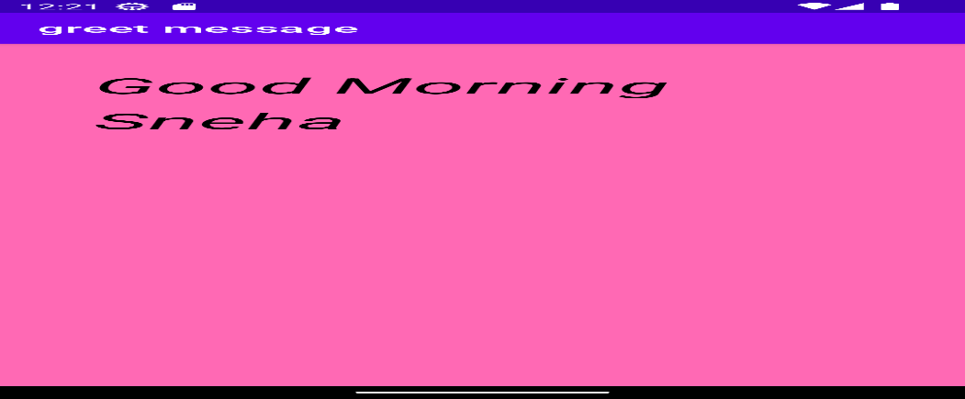

**2. Create a Simple Application Which Send ―Hi message from one activity to another with help of**

**Button (Use Intent).**

**Xml Code**

*<?*xml version="1.0" encoding="utf-8"*?>*<RelativeLayout xmlns:android="http://schemas.android.com/apk/res/android"  
 xmlns:app="http://schemas.android.com/apk/res-auto"  
 xmlns:tools="http://schemas.android.com/tools"  
 android:layout_width="match_parent"  
 android:layout_height="match_parent"  
 tools:context=".MainActivity"  
 android:background="#ADD8E6">  
  
 <Button  
 android:layout_width="100dp"  
 android:layout_height="wrap_content"  
 android:layout_marginTop="125dp"  
 android:layout_marginLeft="150dp"  
 android:id="@+id/b1"  
 android:text="Display"  
 android:textSize="15sp"/>  
</RelativeLayout>

**Java Code**

package com.example.hiimessage;  
  
import androidx.appcompat.app.AppCompatActivity;  
  
import android.content.Intent;  
import android.os.Bundle;  
import android.widget.Button;  
  
  
public class MainActivity extends AppCompatActivity {  
 Button submit;  
 @Override  
 protected void onCreate(Bundle savedInstanceState) {  
 super.onCreate(savedInstanceState);  
 setContentView(R.layout.*activity_main*);  
 submit=findViewById(R.id.*b1*);  
 submit.setOnClickListener((view -> {  
 Intent intent=new Intent(getApplicationContext(),second_activity.class);  
 startActivity(intent);  
 }));  
 }  
}

**Xml Code2**

*<?*xml version="1.0" encoding="utf-8"*?>*<RelativeLayout xmlns:android="http://schemas.android.com/apk/res/android"  
 xmlns:app="http://schemas.android.com/apk/res-auto"  
 xmlns:tools="http://schemas.android.com/tools"  
 android:layout_width="match_parent"  
 android:layout_height="match_parent"  
 tools:context=".second_activity"  
 android:background="#ADD8E6">  
 <TextView  
 android:layout_width="300dp"  
 android:layout_height="50dp"  
 android:id="@+id/t2"  
 android:layout_marginTop="50dp"  
 android:layout_marginLeft="50dp"  
 android:textSize="40sp"  
 android:textStyle="italic"  
 android:layout_marginStart="40dp"  
 android:text="Hi"  
 android:textColor="#DA70D6"/>  
</RelativeLayout>

**Java code2**

package com.example.hiimessage;  
  
import androidx.appcompat.app.AppCompatActivity;  
  
import android.content.Intent;  
import android.os.Bundle;  
  
  
public class second_activity extends AppCompatActivity {  
  
 @Override  
 protected void onCreate(Bundle savedInstanceState) {  
 super.onCreate(savedInstanceState);  
 setContentView(R.layout.*activity_second*);  
 Intent intent=getIntent();  
 }  
}

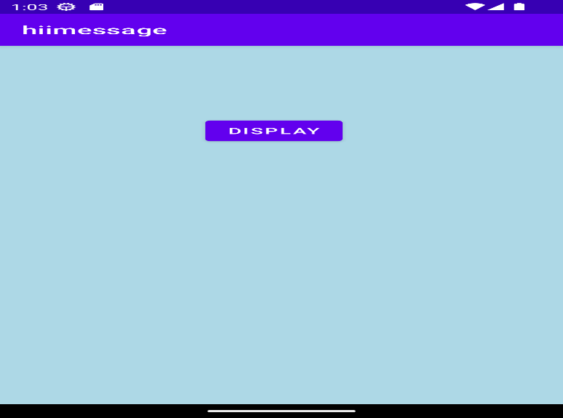

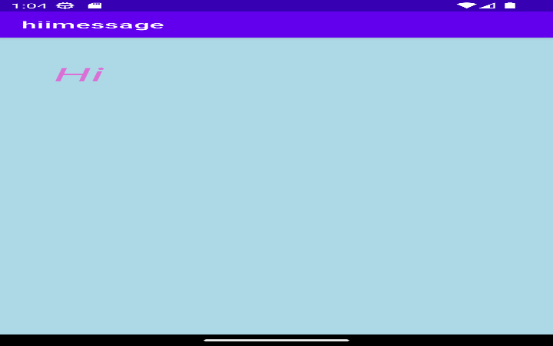

**4. Create an Android App, it reads the Students Details (Name, Surname, Class, Gender, Hobbies,**

**Marks) and display the all information in another activity in table format on click of**

**Submit button.**

**Xml Code**

*<?*xml version="1.0" encoding="utf-8"*?>*<RelativeLayout xmlns:android="http://schemas.android.com/apk/res/android"  
 xmlns:app="http://schemas.android.com/apk/res-auto"  
 xmlns:tools="http://schemas.android.com/tools"  
 android:layout_width="match_parent"  
 android:layout_height="match_parent"  
 tools:context=".MainActivity"  
 android:background="#DDA0DD">  
  
 <TextView  
 android:layout_width="wrap_content"  
 android:layout_height="wrap_content"  
 android:id="@+id/t1"  
 android:text="Name:"  
 android:textSize="20sp"  
 android:textStyle="bold"  
 android:layout_marginTop="15dp"  
 android:layout_marginLeft="15dp"/>  
 <EditText  
 android:layout_width="match_parent"  
 android:layout_height="wrap_content"  
 android:layout_marginLeft="80dp"  
 android:layout_marginTop="3dp"  
 android:layout_marginRight="10dp"  
 android:id="@+id/etname" />  
 <TextView  
 android:layout_width="wrap_content"  
 android:layout_height="wrap_content"  
 android:id="@+id/t2"  
 android:text="Surname:"  
 android:textSize="20sp"  
 android:textStyle="bold"  
 android:layout_below="@id/t1"  
 android:layout_marginLeft="15dp"  
 android:layout_marginTop="20dp"/>  
 <EditText  
 android:layout_width="match_parent"  
 android:layout_height="wrap_content"  
 android:layout_marginLeft="105dp"  
 android:layout_marginTop="3dp"  
 android:layout_marginRight="10dp"  
 android:id="@+id/etsurname"  
 android:layout_below="@id/etname"/>  
 <TextView  
 android:layout_width="wrap_content"  
 android:layout_height="wrap_content"  
 android:id="@+id/t3"  
 android:text="Class:"  
 android:textSize="20sp"  
 android:textStyle="bold"  
 android:layout_below="@id/t2"  
 android:layout_marginLeft="15dp"  
 android:layout_marginTop="20dp"/>  
 <Spinner  
 android:layout_width="wrap_content"  
 android:layout_height="wrap_content"  
 android:id="@+id/s1"  
 android:layout_below="@id/etsurname"  
 android:layout_marginLeft="80dp"  
 android:layout_marginTop="15dp"  
 android:entries="@array/class_name"/>  
 <TextView  
 android:layout_width="wrap_content"  
 android:layout_height="wrap_content"  
 android:id="@+id/t4"  
 android:text="Hobbies:"  
 android:textSize="20sp"  
 android:textStyle="bold"  
 android:layout_below="@id/t3"  
 android:layout_marginLeft="15dp"  
 android:layout_marginTop="20dp"/>  
 <Spinner  
 android:layout_width="wrap_content"  
 android:layout_height="wrap_content"  
 android:id="@+id/s2"  
 android:layout_below="@id/s1"  
 android:layout_marginLeft="110dp"  
 android:layout_marginTop="22dp"  
 android:entries="@array/hobbies"/>  
 <TextView  
 android:layout_width="wrap_content"  
 android:layout_height="wrap_content"  
 android:id="@+id/t5"  
 android:text="Gender:"  
 android:textSize="20sp"  
 android:textStyle="bold"  
 android:layout_below="@id/t4"  
 android:layout_marginLeft="15dp"  
 android:layout_marginTop="20dp"/>  
 <RadioGroup  
 android:id="@+id/radioGrp"  
 android:layout_width="wrap_content"  
 android:layout_height="wrap_content"  
 android:orientation="horizontal"  
 android:layout_below="@id/s2"  
 android:layout_marginLeft="100dp"  
 android:layout_marginTop="15dp">  
 <RadioButton  
 android:id="@+id/radioM"  
 android:layout_width="wrap_content"  
 android:layout_height="wrap_content"  
 android:layout_gravity="left"  
 android:checked="true"  
 android:layout_weight="1"  
 android:textSize="14dp"  
 android:text="Male" />  
 <RadioButton  
 android:id="@+id/radioF"  
 android:layout_width="wrap_content"  
 android:layout_height="wrap_content"  
 android:layout_gravity="right"  
 android:checked="false"  
 android:layout_weight="1"  
 android:textSize="14dp"  
 android:text="Female"/>  
 </RadioGroup>  
 <TextView  
 android:layout_width="wrap_content"  
 android:layout_height="wrap_content"  
 android:id="@+id/t6"  
 android:text="Marks:"  
 android:textSize="20sp"  
 android:textStyle="bold"  
 android:layout_below="@id/t5"  
 android:layout_marginLeft="15dp"  
 android:layout_marginTop="30dp"/>  
 <EditText  
 android:layout_width="match_parent"  
 android:layout_height="wrap_content"  
 android:layout_marginLeft="90dp"  
 android:layout_marginTop="3dp"  
 android:layout_marginRight="10dp"  
 android:id="@+id/etmarks"  
 android:layout_below="@id/radioGrp"  
 android:inputType="number"/>  
 <Button  
 android:layout_width="wrap_content"  
 android:layout_height="wrap_content"  
 android:id="@+id/submitbtn"  
 android:text="Submit"  
 android:layout_below="@id/etmarks"  
 android:layout_marginLeft="150dp"  
 android:layout_marginTop="20dp"/>  
</RelativeLayout>

**String.xml**

<resources>  
 <string name="app_name">Student_details</string>  
 <string-array name="class_name">  
 <item>BSc(CS)</item>  
 <item>BCA</item>  
 <item>BBA</item>  
 <item>MSc(CA)</item>  
 <item>MBA</item>  
 </string-array>  
 <string-array name="hobbies">  
 <item>Reading</item>  
 <item>Trekking</item>  
 <item>Blogging</item>  
 <item>Learning new language</item>  
 <item>Gardening</item>  
 </string-array>  
</resources>

**Java code**

package com.example.student_details;  
  
import androidx.appcompat.app.AppCompatActivity;  
  
import android.os.Bundle;  
import android.content.Intent;  
import android.widget.ArrayAdapter;  
import android.widget.Button;  
import android.widget.EditText;  
import android.widget.RadioButton;  
import android.widget.RadioGroup;  
import android.widget.Spinner;  
import android.view.View;  
import android.widget.TextView;  
  
  
public class MainActivity extends AppCompatActivity {  
 TextView txt1,txt2,txt3,txt4,txt5,txt6;  
 EditText name,lastname,marks;  
 Button submit;  
 Spinner sp1,sp2;  
 RadioGroup rdg;  
 RadioButton rdbm,rdbf;  
 String text;  
  
  
 @Override  
 protected void onCreate(Bundle savedInstanceState) {  
 super.onCreate(savedInstanceState);  
 setContentView(R.layout.*activity_main*);  
 txt1 = findViewById(R.id.*t1*);  
 txt2 = findViewById(R.id.*t2*);  
 txt3 = findViewById(R.id.*t3*);  
 txt4 = findViewById(R.id.*t4*);  
 txt5 = findViewById(R.id.*t5*);  
 txt6 = findViewById(R.id.*t6*);  
 sp1 = findViewById(R.id.*s1*);  
 sp2 = findViewById(R.id.*s2*);  
 name = findViewById(R.id.*etname*);  
 lastname= findViewById(R.id.*etsurname*);  
 marks = findViewById(R.id.*etmarks*);  
 rdg=findViewById(R.id.*radioGrp*);  
 rdbm=findViewById(R.id.*radioM*);  
 rdbf=findViewById(R.id.*radioF*);  
 submit= findViewById(R.id.*submitbtn*);  
 ArrayAdapter adapter = ArrayAdapter.*createFromResource*(this,R.array.*class_name*, android.R.layout.*simple_spinner_dropdown_item*);  
 ArrayAdapter adapter1 = ArrayAdapter.*createFromResource*(this,R.array.*hobbies*, android.R.layout.*simple_spinner_dropdown_item*);  
 submit.setOnClickListener(new View.OnClickListener() {  
 @Override  
 public void onClick(View v) {  
 int selectedRadioButtonId= rdg.getCheckedRadioButtonId();  
 switch(selectedRadioButtonId){  
 case R.id.*radioM*:  
 text = "male";  
  
 break;  
 case R.id.*radioF*:  
 text = "female";  
 break;  
 }  
 String str=name.getText().toString();  
 String str1 =lastname.getText().toString();  
 String str2 =marks.getText().toString();  
 String str3 =sp1.getSelectedItem().toString();  
 String str4 =sp2.getSelectedItem().toString();  
 Intent intent= new Intent(MainActivity.this,SecondActivity.class);  
 intent.putExtra("message",str);  
 intent.putExtra("message1",str1);  
 intent.putExtra("message2",str2);  
 intent.putExtra("message3",str3);  
 intent.putExtra("message4",str4);  
 intent.putExtra("message5",text);  
 startActivity(intent);  
 }  
 });  
 }  
}

**xml code(second activity)**

*<?*xml version="1.0" encoding="utf-8"*?>*<TableLayout xmlns:android="http://schemas.android.com/apk/res/android"  
 xmlns:app="http://schemas.android.com/apk/res-auto"  
 xmlns:tools="http://schemas.android.com/tools"  
 android:layout_width="match_parent"  
 android:layout_height="match_parent"  
 tools:context=".SecondActivity"  
 android:background="#DDA0DD"  
 android:paddingRight="10dp"  
 android:paddingLeft="10dp">  
  
 <TableRow  
 android:layout_width="match_parent"  
 android:layout_height="wrap_content"  
 android:layout_marginTop="20dp">  
 <TextView  
 android:id="@+id/txtv1"  
 android:text="Name"  
 android:layout_marginLeft="15dp"  
 android:textStyle="bold"  
 android:layout_row="0"  
 android:layout_column="0"  
 android:layout_width="wrap_content"  
 android:layout_height="wrap_content" />  
 <TextView  
 android:id="@+id/txtv2"  
 android:text=""  
 android:layout_marginLeft="20dp"  
 android:textStyle="bold"  
 android:layout_row="0"  
 android:layout_column="1"  
 android:layout_width="wrap_content"  
 android:layout_height="wrap_content" />  
 </TableRow>  
 <TableRow  
 android:layout_width="match_parent"  
 android:layout_height="wrap_content"  
 android:layout_marginTop="20dp">  
 <TextView  
 android:id="@+id/txtv3"  
 android:text="Surname"  
 android:layout_marginLeft="15dp"  
 android:textStyle="bold"  
 android:layout_row="1"  
 android:layout_column="0"  
 android:layout_width="wrap_content"  
 android:layout_height="wrap_content"/>  
 <TextView  
 android:id="@+id/txtv4"  
 android:text=""  
 android:layout_marginLeft="20dp"  
 android:textStyle="bold"  
 android:layout_row="1"  
 android:layout_column="1"  
 android:layout_width="wrap_content"  
 android:layout_height="wrap_content"/>  
 </TableRow>  
 <TableRow  
 android:layout_width="match_parent"  
 android:layout_height="wrap_content"  
 android:layout_marginTop="20dp">  
 <TextView  
 android:id="@+id/txtv5"  
 android:text="Class"  
 android:layout_marginLeft="15dp"  
 android:textStyle="bold"  
 android:layout_row="2"  
 android:layout_column="0"  
 android:layout_width="wrap_content"  
 android:layout_height="wrap_content"/>  
 <TextView  
 android:id="@+id/txtv6"  
 android:text=""  
 android:layout_marginLeft="20dp"  
 android:textStyle="bold"  
 android:layout_row="2"  
 android:layout_column="1"  
 android:layout_width="wrap_content"  
 android:layout_height="wrap_content"/>  
 </TableRow>  
 <TableRow  
 android:layout_width="match_parent"  
 android:layout_height="wrap_content"  
 android:layout_marginTop="20dp">  
 <TextView  
 android:id="@+id/txtv7"  
 android:text="Hobbies"  
 android:layout_marginLeft="15dp"  
 android:textStyle="bold"  
 android:layout_row="3"  
 android:layout_column="0"  
 android:layout_width="wrap_content"  
 android:layout_height="wrap_content"/>  
 <TextView  
 android:id="@+id/txtv8"  
 android:text=""  
 android:layout_marginLeft="20dp"  
 android:textStyle="bold"  
 android:layout_row="3"  
 android:layout_column="1"  
 android:layout_width="wrap_content"  
 android:layout_height="wrap_content"/>  
 </TableRow>  
 <TableRow  
 android:layout_width="match_parent"  
 android:layout_height="wrap_content"  
 android:layout_marginTop="20dp">  
 <TextView  
 android:id="@+id/txtv9"  
 android:text="Gender"  
 android:layout_marginLeft="15dp"  
 android:textStyle="bold"  
 android:layout_row="4"  
 android:layout_column="0"  
 android:layout_width="wrap_content"  
 android:layout_height="wrap_content"/>  
 <TextView  
 android:id="@+id/txtv10"  
 android:text=""  
 android:layout_marginLeft="20dp"  
 android:textStyle="bold"  
 android:layout_row="4"  
 android:layout_column="1"  
 android:layout_width="wrap_content"  
 android:layout_height="wrap_content"/>  
 </TableRow>  
 <TableRow  
 android:layout_width="match_parent"  
 android:layout_height="wrap_content"  
 android:layout_marginTop="20dp">  
 <TextView  
 android:id="@+id/txtv11"  
 android:text="Marks"  
 android:layout_marginLeft="15dp"  
 android:textStyle="bold"  
 android:layout_row="5"  
 android:layout_column="0"  
 android:layout_width="wrap_content"  
 android:layout_height="wrap_content"/>  
 <TextView  
 android:id="@+id/txtv12"  
 android:text=""  
 android:layout_marginLeft="20dp"  
 android:textStyle="bold"  
 android:layout_row="5"  
 android:layout_column="1"  
 android:layout_width="wrap_content"  
 android:layout_height="wrap_content"/>  
 </TableRow>  
</TableLayout>

**Java code**

package com.example.student_details;  
  
import androidx.appcompat.app.AppCompatActivity;  
  
import android.os.Bundle;  
import android.content.Intent;  
import android.widget.TextView;  
  
  
public class SecondActivity extends AppCompatActivity {  
 TextView tname,tlastname,tclass,thobby,tgender,tmarks;  
 @Override  
 protected void onCreate(Bundle savedInstanceState) {  
 super.onCreate(savedInstanceState);  
 setContentView(R.layout.*activity_second*);  
 tname= findViewById(R.id.*txtv2*);  
 tlastname= findViewById(R.id.*txtv4*);  
 tclass= findViewById(R.id.*txtv6*);  
 thobby= findViewById(R.id.*txtv8*);  
 tgender= findViewById(R.id.*txtv10*);  
 tmarks=findViewById(R.id.*txtv12*);  
 Intent intent= getIntent();  
 String str= intent.getStringExtra("message");  
 tname.setText(str);  
 String str1= intent.getStringExtra("message1");  
 tlastname.setText(str1);  
 String str2= intent.getStringExtra("message2");  
 tmarks.setText(str2);  
 String str3= intent.getStringExtra("message3");  
 tclass.setText(str3);  
 String str4= intent.getStringExtra("message4");  
 thobby.setText(str4);  
 String text= intent.getStringExtra("message5");  
 tgender.setText(text);  
 }  
}  
  
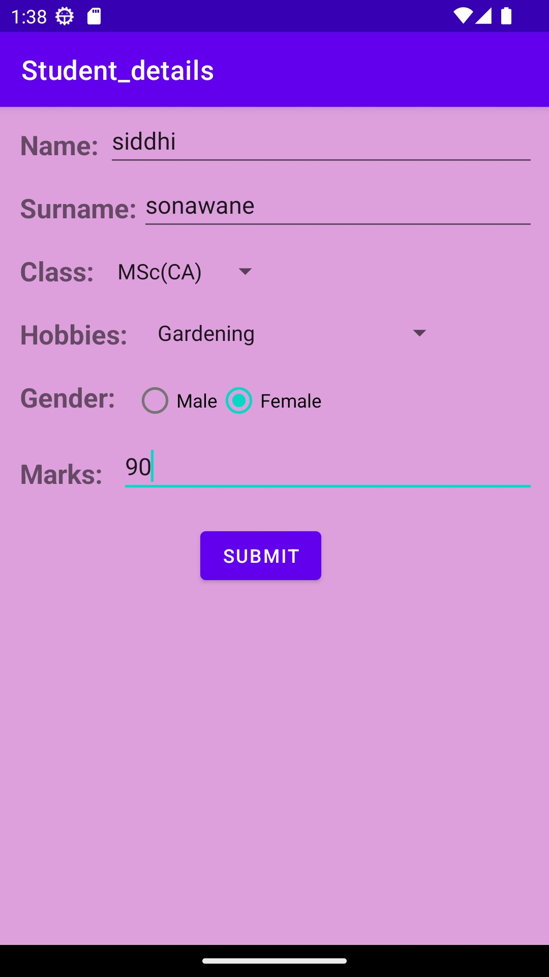

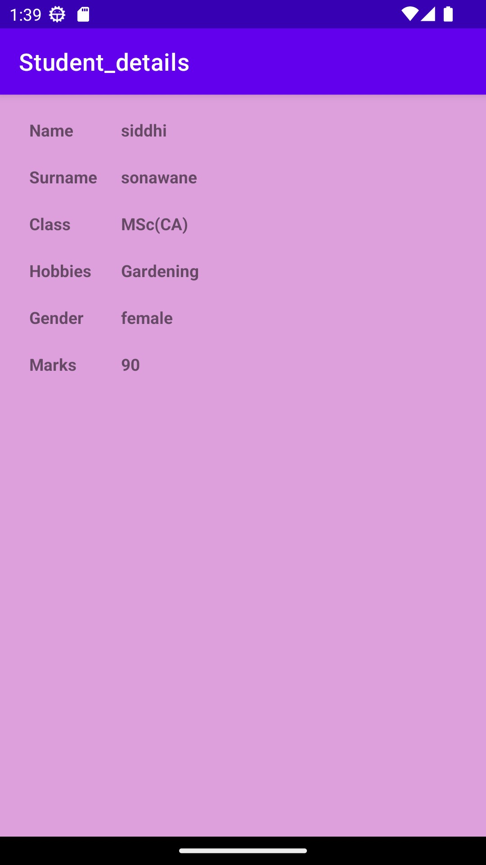

**5. Create an Android Application that accept multiple items from one activity and pass to next activity**

**and display the calculation of the first and second activity data on third.**

**Xml file**

*<?*xml version="1.0" encoding="utf-8"*?>*<RelativeLayout xmlns:android="http://schemas.android.com/apk/res/android"  
 xmlns:app="http://schemas.android.com/apk/res-auto"  
 xmlns:tools="http://schemas.android.com/tools"  
 android:layout_width="match_parent"  
 android:layout_height="match_parent"  
 android:orientation="vertical"  
 tools:context=".MainActivity">  
  
 <TextView  
 android:id="@+id/txt1"  
 android:layout_width="wrap_content"  
 android:layout_height="wrap_content"  
 android:layout_marginLeft="50dp"  
 android:layout_marginTop="50dp"  
 android:text="Item1"  
 android:textSize="30dp"></TextView>  
  
 <CheckBox  
 android:id="@+id/chk1"  
 android:layout_width="wrap_content"  
 android:layout_height="wrap_content"  
 android:layout_marginLeft="150dp"  
 android:layout_marginTop="50dp"  
 android:text="watch"  
 android:textSize="30dp">  
  
 </CheckBox>  
 <TextView  
 android:id="@+id/txt2"  
 android:layout_below="@+id/txt1"  
 android:layout_width="wrap_content"  
 android:layout_height="wrap_content"  
 android:layout_marginLeft="50dp"  
 android:layout_marginTop="50dp"  
 android:text="Item2"  
 android:textSize="30dp"></TextView>  
  
 <CheckBox  
 android:id="@+id/chk2"  
 android:layout_width="wrap_content"  
 android:layout_height="wrap_content"  
 android:layout_marginLeft="150dp"  
 android:layout_marginTop="50dp"  
 android:text="stationary"  
 android:layout_below="@id/chk1"  
 android:textSize="30dp">  
  
 </CheckBox>  
 <TextView  
 android:id="@+id/txt3"  
 android:layout_below="@+id/txt2"  
 android:layout_width="wrap_content"  
 android:layout_height="wrap_content"  
 android:layout_marginLeft="50dp"  
 android:layout_marginTop="50dp"  
 android:text="Item3"  
 android:textSize="30dp"></TextView>  
  
 <CheckBox  
 android:id="@+id/chk3"  
 android:layout_width="wrap_content"  
 android:layout_height="wrap_content"  
 android:layout_marginLeft="150dp"  
 android:layout_marginTop="50dp"  
 android:text="Cloths"  
 android:layout_below="@id/chk2"  
 android:textSize="30dp">  
  
 </CheckBox>  
 <Button  
 android:id="@+id/btn1"  
 android:layout_marginLeft="150dp"  
 android:layout_marginTop="50dp"  
 android:layout_below="@id/chk3"  
 android:layout_width="wrap_content"  
 android:layout_height="wrap_content"  
 android:text="Calculate_1"  
 android:textSize="30dp"  
 android:gravity="bottom"></Button>  
 <TextView  
 android:layout_width="wrap_content"  
 android:layout_height="wrap_content"  
 android:text="Hello World!" />  
  
</RelativeLayout>

**Java file**

package com.example.intent_calculate_third;  
import android.support.v7.app.AppCompatActivity;  
import android.os.Bundle;  
import android.widget.TextView;  
import android.widget.CheckBox;  
import android.widget.Button;  
import android.content.Intent;  
import android.view.View;  
public class MainActivity extends AppCompatActivity {  
 private CheckBox ch1,ch2,ch3;  
 private Button b1;  
 @Override  
 protected void onCreate(Bundle savedInstanceState) {  
 super.onCreate(savedInstanceState);  
 setContentView(R.layout.*activity_main*);  
 ch1=findViewById(R.id.*chk1*);  
 ch2=findViewById(R.id.*chk2*);  
 ch3=findViewById(R.id.*chk3*);  
 b1=findViewById(R.id.*btn1*);  
 b1.setOnClickListener(new View.OnClickListener() {  
 @Override  
 public void onClick(View view) {  
 int sel_cnt=0;  
 if(ch1.isChecked()){  
 sel_cnt=sel_cnt+200;  
 }  
 if(ch2.isChecked()){  
 sel_cnt=sel_cnt+1200;  
 }  
 if(ch3.isChecked()){  
 sel_cnt=sel_cnt+5000;  
 }  
 Intent i=new Intent(MainActivity.this,MainActivity2.class);  
 i.putExtra("page_one_count",sel_cnt);  
 startActivity(i);  
 }  
 });  
  
 }  
  
}

**xml code2**

*<?*xml version="1.0" encoding="utf-8"*?>*<RelativeLayout xmlns:android="http://schemas.android.com/apk/res/android"  
 xmlns:app="http://schemas.android.com/apk/res-auto"  
 xmlns:tools="http://schemas.android.com/tools"  
 android:layout_width="match_parent"  
 android:layout_height="match_parent"  
 tools:context=".MainActivity2"  
 android:orientation="vertical">  
 <TextView  
 android:id="@+id/txt4"  
 android:layout_width="wrap_content"  
 android:layout_height="wrap_content"  
 android:layout_marginLeft="50dp"  
 android:layout_marginTop="50dp"  
 android:text="Item4"  
 android:textSize="30dp"></TextView>  
 <CheckBox  
 android:id="@+id/chk4"  
 android:layout_width="wrap_content"  
 android:layout_height="wrap_content"  
 android:layout_marginLeft="150dp"  
 android:layout_marginTop="50dp"  
 android:text="shoes"  
 android:textSize="30dp">  
 </CheckBox>  
 <TextView  
 android:id="@+id/txt5"  
 android:layout_below="@+id/txt4"  
 android:layout_width="wrap_content"  
 android:layout_height="wrap_content"  
 android:layout_marginLeft="50dp"  
 android:layout_marginTop="50dp"  
 android:text="Item5"  
 android:textSize="30dp"></TextView>  
  
 <CheckBox  
 android:id="@+id/chk5"  
 android:layout_width="wrap_content"  
 android:layout_height="wrap_content"  
 android:layout_marginLeft="150dp"  
 android:layout_marginTop="50dp"  
 android:text="cosmetics"  
 android:layout_below="@id/chk4"  
 android:textSize="30dp">  
  
 </CheckBox>  
 <TextView  
 android:id="@+id/txt6"  
 android:layout_below="@+id/txt5"  
 android:layout_width="wrap_content"  
 android:layout_height="wrap_content"  
 android:layout_marginLeft="50dp"  
 android:layout_marginTop="50dp"  
 android:text="Item6"  
 android:textSize="30dp"></TextView>  
  
 <CheckBox  
 android:id="@+id/chk6"  
 android:layout_width="wrap_content"  
 android:layout_height="wrap_content"  
 android:layout_marginLeft="150dp"  
 android:layout_marginTop="50dp"  
 android:text="other "  
 android:layout_below="@id/chk5"  
 android:textSize="30dp">  
  
 </CheckBox>  
<Button  
 android:id="@+id/btn2"  
 android:layout_marginLeft="150dp"  
 android:layout_marginTop="50dp"  
 android:layout_below="@id/chk6"  
 android:layout_width="wrap_content"  
 android:layout_height="wrap_content"  
 android:text="Calculate_2"  
 android:textSize="30dp"  
 android:gravity="bottom"></Button>  
</RelativeLayout>

**Java code2**

package com.example.intent_calculate_third;  
import android.support.v7.app.AppCompatActivity;  
import android.os.Bundle;  
import android.widget.TextView;  
import android.widget.CheckBox;  
import android.widget.Button;  
import android.content.Intent;  
import android.view.View;  
public class MainActivity2 extends AppCompatActivity {  
 private CheckBox ch4,ch5,ch6;  
 private Button b2;  
 @Override  
 protected void onCreate(Bundle savedInstanceState) {  
 super.onCreate(savedInstanceState);  
 setContentView(R.layout.*activity_main2*);  
 ch4=findViewById(R.id.*chk4*);  
 ch5=findViewById(R.id.*chk5*);  
 ch6=findViewById(R.id.*chk6*);  
 b2=findViewById(R.id.*btn2*);  
 b2.setOnClickListener(new View.OnClickListener() {  
 @Override  
 public void onClick(View view) {  
 int sel_cnt2=0;  
 if(ch4.isChecked()){  
 sel_cnt2=sel_cnt2+2778;  
 }  
 if(ch5.isChecked()){  
 sel_cnt2=sel_cnt2+12560;  
 }  
 if(ch6.isChecked()){  
 sel_cnt2=sel_cnt2+5000;  
 }  
 Intent i=new Intent(MainActivity2.this,MainActivity3.class);  
 int page_1=getIntent().getIntExtra("page_one_count",0);  
 i.putExtra("page_one_count",page_1);  
 i.putExtra("page_two_count",sel_cnt2);  
  
 startActivity(i);  
 }  
 });  
 }  
}

**xml code3**

*<?*xml version="1.0" encoding="utf-8"*?>*<LinearLayout xmlns:android="http://schemas.android.com/apk/res/android"  
 xmlns:app="http://schemas.android.com/apk/res-auto"  
 xmlns:tools="http://schemas.android.com/tools"  
 android:layout_width="match_parent"  
 android:layout_height="match_parent"  
 tools:context=".MainActivity3"  
 android:orientation="vertical">  
 <TextView  
 android:id="@+id/txt7"  
 android:layout_marginLeft="30dp"  
 android:layout_marginTop="50dp"  
 android:layout_width="match_parent"  
 android:layout_height="wrap_content"  
 android:hint="Calculation of Page one"  
 android:textSize="30dp"/>  
 <TextView  
 android:id="@+id/txt8"  
 android:layout_marginLeft="30dp"  
 android:layout_marginTop="50dp"  
 android:layout_width="match_parent"  
 android:layout_height="wrap_content"  
 android:hint="Calculation of Page two"  
 android:textSize="30dp"/>  
 <TextView  
 android:id="@+id/txt9"  
 android:layout_marginLeft="30dp"  
 android:layout_marginTop="50dp"  
 android:layout_width="match_parent"  
 android:layout_height="wrap_content"  
 android:hint="Total of Both the Page"  
 android:textSize="30dp">  
 </TextView>  
</LinearLayout>

**Java code 3**

package com.example.intent_calculate_third;  
import android.support.v7.app.AppCompatActivity;  
import android.os.Bundle;  
import android.content.Intent;  
import android.view.View;  
import android.widget.TextView;  
public class MainActivity3 extends AppCompatActivity {  
private TextView t7,t8,t9;  
  
 @Override  
 protected void onCreate(Bundle savedInstanceState) {  
 super.onCreate(savedInstanceState);  
 setContentView(R.layout.*activity_main3*);  
 t7=findViewById(R.id.*txt7*);  
 t8=findViewById(R.id.*txt8*);  
 t9=findViewById(R.id.*txt9*);  
 int page_1=getIntent().getIntExtra("page_one_count",0);  
 t7.setText("Page one Calculated value is:"+page_1);  
 int page_2=getIntent().getIntExtra("page_two_count",0);  
 t8.setText("Page two Calculated value is:"+page_2);  
 int total=page_1+page_2;  
 t9.setText("The Total of Both Page is:"+total);  
  
 }  
}

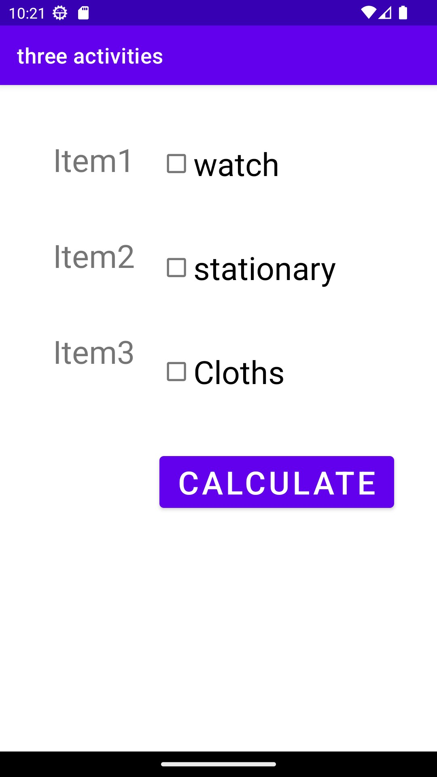

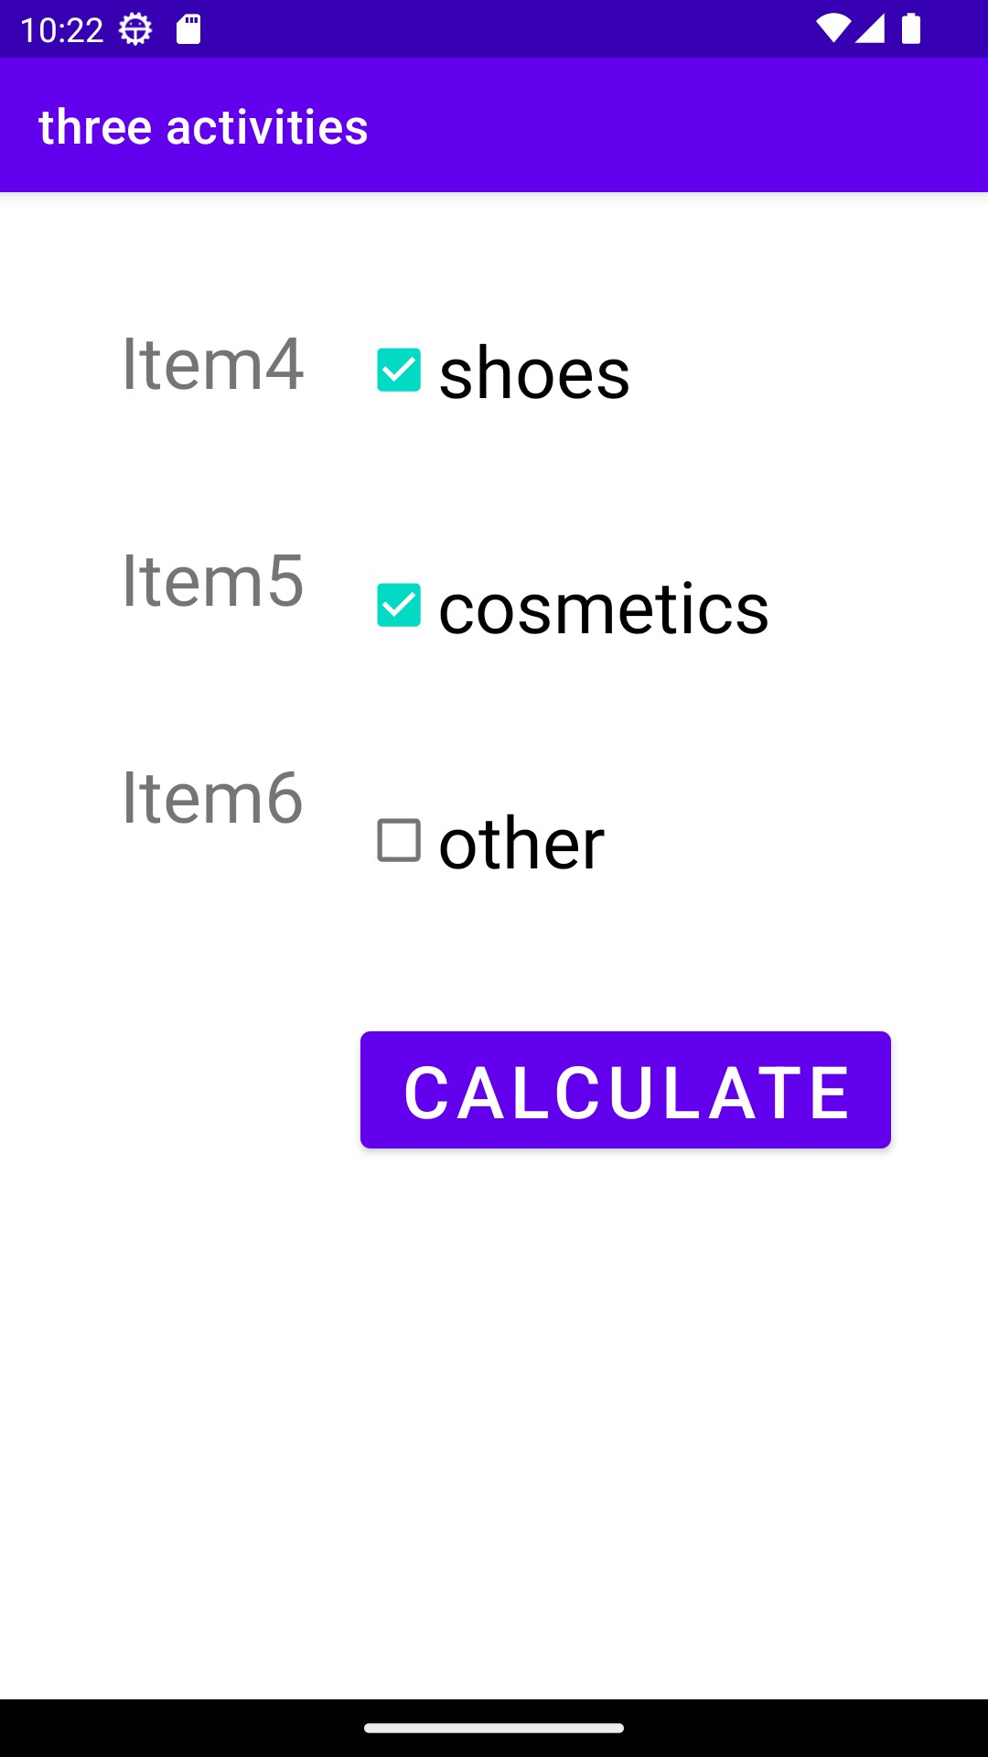

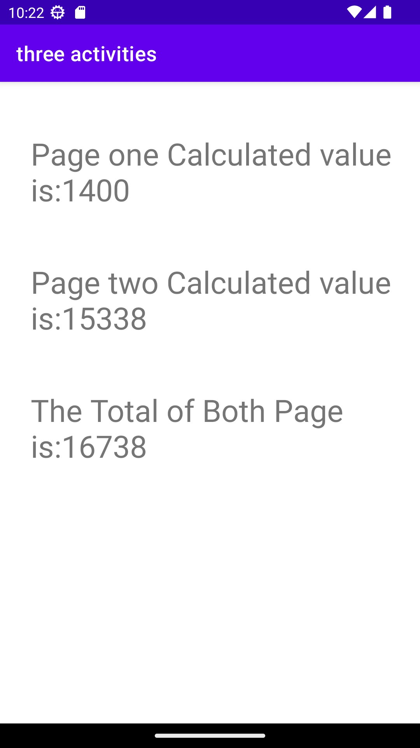

**6. Create First Activity to accept information like Student First Name, Middle Name,**

**Last Name, Date of birth, Address, Email ID and display all information on Second Activity**

**when user click on Submit button.**

**XML Code**

<?xml version="1.0" encoding="utf-8"?>

<RelativeLayout xmlns:android="http://schemas.android.com/apk/res/android"

xmlns:app="http://schemas.android.com/apk/res-auto"

xmlns:tools="http://schemas.android.com/tools"

android:layout_width="match_parent"

android:layout_height="match_parent"

android:background="#FFFACD"

tools:context=".MainActivity">

<TextView

android:layout_width="wrap_content"

android:layout_height="wrap_content"

android:id="@+id/title"

android:text="Student Details"

android:layout_marginTop="30dp"

android:layout_marginLeft="100dp"

android:textColor="@color/black"

android:textStyle="bold"

android:textSize="25sp"/>

<EditText

android:id="@+id/firstNameEditText"

android:layout_width="match_parent"

android:layout_height="wrap_content"

android:hint=" Enter First Name"

android:layout_below="@id/title"

android:layout_marginTop="15dp"

android:layout_marginLeft="15dp"

android:layout_marginRight="15dp"

android:inputType="textPersonName"/>

<EditText

android:id="@+id/middleNameEditText"

android:layout_width="match_parent"

android:layout_height="wrap_content"

android:layout_below="@+id/firstNameEditText"

android:hint=" Enter Middle Name"

android:layout_marginTop="15dp"

android:layout_marginRight="15dp"

android:layout_marginLeft="15dp"

android:inputType="textPersonName"/>

<EditText

android:id="@+id/lastNameEditText"

android:layout_width="match_parent"

android:layout_height="wrap_content"

android:layout_below="@+id/middleNameEditText"

android:hint="Enter Last Name"

android:layout_marginLeft="15dp"

android:layout_marginRight="15dp"

android:layout_marginTop="15dp"

android:inputType="textPersonName"/>

<EditText

android:id="@+id/dateOfBirthEditText"

android:layout_width="match_parent"

android:layout_height="wrap_content"

android:layout_below="@+id/lastNameEditText"

android:hint="Date of Birth (YYYY-MM-DD)"

android:layout_marginTop="15dp"

android:layout_marginRight="15dp"

android:layout_marginLeft="15dp"

android:inputType="date"/>

<EditText

android:id="@+id/addressEditText"

android:layout_width="match_parent"

android:layout_height="wrap_content"

android:layout_below="@+id/dateOfBirthEditText"

android:hint="Enter Address"

android:layout_marginLeft="15dp"

android:layout_marginRight="15dp"

android:layout_marginTop="15dp"

android:inputType="textPostalAddress"/>

<EditText

android:id="@+id/emailEditText"

android:layout_width="match_parent"

android:layout_height="wrap_content"

android:layout_below="@+id/addressEditText"

android:hint="Enter Email ID"

android:layout_marginTop="15dp"

android:layout_marginRight="15dp"

android:layout_marginLeft="15dp"

android:inputType="textEmailAddress"/>

<Button

android:id="@+id/submitButton"

android:layout_width="wrap_content"

android:layout_height="wrap_content"

android:layout_below="@+id/emailEditText"

android:layout_centerHorizontal="true"

android:layout_marginTop="30dp"

android:text="Submit" />

</RelativeLayout>

**Java Code**

package com.example.myapplication;

import androidx.appcompat.app.AppCompatActivity;

import android.os.Bundle;

import android.content.Intent;

import android.view.View;

import android.widget.Button;

import android.widget.EditText;

public class MainActivity extends AppCompatActivity {

EditText firstName1, middleName1, lastName1, dateOfBirth1, address1, email1;

Button submitButton;

@Override

protected void onCreate(Bundle savedInstanceState) {

super.onCreate(savedInstanceState);

setContentView(R.layout.activity_main);

firstName1 = findViewById(R.id.firstNameEditText);

middleName1 = findViewById(R.id.middleNameEditText);

lastName1 = findViewById(R.id.lastNameEditText);

dateOfBirth1 = findViewById(R.id.dateOfBirthEditText);

address1 = findViewById(R.id.addressEditText);

email1 = findViewById(R.id.emailEditText);

submitButton = findViewById(R.id.submitButton);

submitButton.setOnClickListener(new View.OnClickListener() {

@Override

public void onClick(View view) {

String firstName = firstName1.getText().toString();

String middleName = middleName1.getText().toString();

String lastName = lastName1.getText().toString();

String dateOfBirth = dateOfBirth1.getText().toString();

String address = address1.getText().toString();

String email = email1.getText().toString();

Intent intent = new Intent(MainActivity.this, SecondActivity.class);

intent.putExtra("FirstName", firstName);

intent.putExtra("MiddleName", middleName);

intent.putExtra("LastName", lastName);

intent.putExtra("DateOfBirth", dateOfBirth);

intent.putExtra("Address", address);

intent.putExtra("Email", email);

startActivity(intent);

}

});

}

}

**Xml Code 2**

<?xml version="1.0" encoding="utf-8"?>

<LinearLayout xmlns:android="http://schemas.android.com/apk/res/android"

android:layout_width="match_parent"

android:layout_height="match_parent"

android:orientation="vertical"

android:background="#FFFACD">

<TextView

android:id="@+id/displayTextView"

android:layout_width="wrap_content"

android:layout_height="wrap_content"

android:textSize="25sp"

android:textStyle="bold"

android:textColor="@color/black"

android:text="Student Details:"

android:layout_marginLeft="100dp"

android:layout_marginTop="15dp"/>

<TextView

android:id="@+id/displayInfoTextView"

android:layout_width="wrap_content"

android:layout_height="wrap_content"

android:textSize="20sp"

android:layout_marginTop="30dp"

android:text=""

android:textStyle="bold"

android:textColor="@color/black"

android:layout_marginLeft="100dp"/>

</LinearLayout>

**Java Code2**

package com.example.myapplication;

import androidx.appcompat.app.AppCompatActivity;

import android.os.Bundle;

import android.content.Intent;

import android.widget.TextView;

public class SecondActivity extends AppCompatActivity {

TextView InfoTextView;

@Override

protected void onCreate(Bundle savedInstanceState) {

super.onCreate(savedInstanceState);

setContentView(R.layout.activity_second);

InfoTextView = findViewById(R.id.displayInfoTextView);

Intent intent = getIntent();

String firstName = intent.getStringExtra("FirstName");

String middleName = intent.getStringExtra("MiddleName");

String lastName = intent.getStringExtra("LastName");

String dateOfBirth = intent.getStringExtra("DateOfBirth");

String address = intent.getStringExtra("Address");

String email = intent.getStringExtra("Email");

String studentInfo = "First Name: \t" + firstName + "\n" +

"Middle Name: \t" + middleName + "\n" +

"Last Name: \t" + lastName + "\n" +

"Date of Birth: \t" + dateOfBirth + "\n" +

"Address: \t" + address + "\n" +

"Email ID: \t" + email;

InfoTextView.setText(studentInfo);

}

}

**7. Create a Simple Application, which reads a positive number from the user and display its factorial value in another activity.**

**XML code**

*<?*xml version="1.0" encoding="utf-8"*?>*<RelativeLayout xmlns:android="http://schemas.android.com/apk/res/android"  
 xmlns:app="http://schemas.android.com/apk/res-auto"  
 xmlns:tools="http://schemas.android.com/tools"  
 android:layout_width="match_parent"  
 android:layout_height="match_parent"  
 tools:context=".MainActivity">  
  
 <TextView  
 android:id="@+id/title"  
 android:layout_width="wrap_content"  
 android:layout_height="wrap_content"  
 android:text="Factorial of number"  
 android:layout_marginTop="30dp"  
 android:layout_marginLeft="100dp"  
 android:textStyle="bold"  
 android:textColor="@color/black"  
 android:textSize="25sp"/>  
 <TextView  
 android:layout_width="wrap_content"  
 android:layout_height="wrap_content"  
 android:id="@+id/t1"  
 android:text="Enter a positive number :"  
 android:textSize="20sp"  
 android:textColor="@color/black"  
 android:textStyle="bold"  
 android:layout_below="@id/title"  
 android:layout_marginLeft="20dp"  
 android:layout_marginTop="30dp"/>  
 <EditText  
 android:layout_width="150dp"  
 android:layout_height="wrap_content"  
 android:layout_below="@id/title"  
 android:layout_marginTop="20dp"  
 android:layout_marginLeft="250dp"  
 android:id="@+id/e1"  
 android:inputType="number"/>  
 <Button  
 android:layout_width="wrap_content"  
 android:layout_height="wrap_content"  
 android:id="@+id/b1"  
 android:text="Calculate"  
 android:layout_below="@id/t1"  
 android:layout_marginLeft="150dp"  
 android:layout_marginTop="30dp"/>  
  
</RelativeLayout>

**Java Code**

package com.example.factorial;  
import androidx.appcompat.app.AppCompatActivity;  
import android.content.Intent;  
import android.os.Bundle;  
import android.view.View;  
import android.widget.Button;  
import android.widget.EditText;  
public class MainActivity extends AppCompatActivity {  
 EditText editTextNumber;  
 Button buttonCalculate;  
 @Override  
 protected void onCreate(Bundle savedInstanceState) {  
 super.onCreate(savedInstanceState);  
 setContentView(R.layout.*activity_main*);  
 editTextNumber = findViewById(R.id.*e1*);  
 buttonCalculate = findViewById(R.id.*b1*);  
 buttonCalculate.setOnClickListener(new View.OnClickListener() {  
 @Override  
 public void onClick(View view) {  
 String userInput = editTextNumber.getText().toString();  
 if (!userInput.isEmpty()) {  
 int number = Integer.*parseInt*(userInput);  
 int factorial = calculateFactorial(number);  
 Intent intent = new Intent(MainActivity.this, SecondActivity.class);  
 intent.putExtra("factorial", factorial);  
 startActivity(intent);  
 }  
 }  
 });  
 }  
 int calculateFactorial(int n) {  
 if (n == 0 || n == 1) {  
 return 1;  
 }  
 return n * calculateFactorial(n - 1);  
 }  
}

**XML Code2**

*<?*xml version="1.0" encoding="utf-8"*?>*<RelativeLayout xmlns:android="http://schemas.android.com/apk/res/android"  
 xmlns:app="http://schemas.android.com/apk/res-auto"  
 xmlns:tools="http://schemas.android.com/tools"  
 android:layout_width="match_parent"  
 android:layout_height="match_parent"  
 tools:context=".SecondActivity">  
 <TextView  
 android:layout_width="200dp"  
 android:layout_height="150dp"  
 android:layout_marginTop="50dp"  
 android:layout_marginLeft="100dp"  
 android:id="@+id/tvresult"  
 android:textStyle="bold"  
 android:textSize="25sp"  
 android:textColor="@color/black"  
 android:text=""/>  
</RelativeLayout>

**Java Code2**

package com.example.factorial;  
  
import androidx.appcompat.app.AppCompatActivity;  
import android.content.Intent;  
import android.os.Bundle;  
import android.widget.TextView;  
  
public class SecondActivity extends AppCompatActivity {  
  
 @Override  
 protected void onCreate(Bundle savedInstanceState) {  
 super.onCreate(savedInstanceState);  
 setContentView(R.layout.*activity_second*);  
 TextView textViewResult = findViewById(R.id.*tvresult*);  
 Intent intent = getIntent();  
 int factorial = intent.getIntExtra("factorial", 0);  
 textViewResult.setText("Factorial is : \t" + factorial);  
 }  
}

**8. Create an Android Application to accept two numbers and find power and Average.**

**Display the result on the next activity on Button click.**

**XML code**

<?xml version="1.0" encoding="utf-8"?>

<RelativeLayout xmlns:android="http://schemas.android.com/apk/res/android"

xmlns:app="http://schemas.android.com/apk/res-auto"

xmlns:tools="http://schemas.android.com/tools"

android:layout_width="match_parent"

android:layout_height="match_parent"

tools:context=".MainActivity"

android:background="#6495ED">

<TextView

android:id="@+id/t1"

android:layout_width="wrap_content"

android:layout_height="wrap_content"

android:text="Power and Average of Numbers"

android:textSize="25sp"

android:textColor="@color/black"

android:layout_marginTop="30dp"

android:layout_marginLeft="25dp"/>

<TextView

android:id="@+id/t2"

android:layout_width="wrap_content"

android:layout_height="wrap_content"

android:text="Enter the first number :"

android:layout_below="@id/t1"

android:layout_marginTop="30dp"

android:layout_marginLeft="15dp"

android:textColor="@color/black"

android:textStyle="bold"/>

<EditText

android:layout_width="350dp"

android:layout_height="wrap_content"

android:id="@+id/e1"

android:layout_marginLeft="200dp"

android:layout_below="@id/t1"

android:layout_marginRight="100dp"

android:layout_marginTop="10dp"

android:inputType="numberDecimal"/>

<TextView

android:id="@+id/t3"

android:layout_width="wrap_content"

android:layout_height="wrap_content"

android:text="Enter the second number :"

android:layout_below="@id/t2"

android:layout_marginTop="30dp"

android:layout_marginLeft="15dp"

android:textColor="@color/black"

android:textStyle="bold"/>

<EditText

android:layout_width="350dp"

android:layout_height="wrap_content"

android:id="@+id/e2"

android:layout_marginLeft="210dp"

android:layout_below="@id/e1"

android:layout_marginRight="100dp"

android:layout_marginTop="10dp"

android:inputType="numberDecimal"/>

<Button

android:layout_width="wrap_content"

android:layout_height="wrap_content"

android:id="@+id/b1"

android:text="Calculate"

android:layout_below="@id/t3"

android:layout_marginTop="30dp"

android:layout_marginLeft="150dp"/>

</RelativeLayout>

**Java Code**

package com.example.myapplication;

import androidx.appcompat.app.AppCompatActivity;

import android.content.Intent;

import android.os.Bundle;

import android.view.View;

import android.widget.Button;

import android.widget.EditText;

public class MainActivity extends AppCompatActivity {

EditText edt1,edt2;

Button cal;

@Override

protected void onCreate(Bundle savedInstanceState) {

super.onCreate(savedInstanceState);

setContentView(R.layout.activity_main);

edt1=findViewById(R.id.e1);

edt2=findViewById(R.id.e2);

cal=findViewById(R.id.b1);

cal.setOnClickListener(new View.OnClickListener() {

@Override

public void onClick(View view) {

Intent intent=new Intent(MainActivity.this,SecondActivity.class);

intent.putExtra("number1",edt1.getText().toString());

intent.putExtra("number2",edt2.getText().toString());

startActivity(intent);

}

});

}

}

**XML Code2**

<?xml version="1.0" encoding="utf-8"?>

<RelativeLayout xmlns:android="http://schemas.android.com/apk/res/android"

xmlns:app="http://schemas.android.com/apk/res-auto"

xmlns:tools="http://schemas.android.com/tools"

android:layout_width="match_parent"

android:layout_height="match_parent"

tools:context=".SecondActivity"

android:background="#6495ED">

<TextView

android:layout_width="200dp"

android:layout_height="wrap_content"

android:layout_marginTop="50dp"

android:layout_marginLeft="100dp"

android:textStyle="bold"

android:textColor="@color/black"

android:id="@+id/t9"/>

<TextView

android:layout_width="200dp"

android:layout_height="wrap_content"

android:layout_marginTop="50dp"

android:layout_marginLeft="100dp"

android:textStyle="bold"

android:textColor="@color/black"

android:id="@+id/t90"

android:layout_below="@id/t9"/>

</RelativeLayout>

**Java Code2**

package com.example.myapplication;

import androidx.appcompat.app.AppCompatActivity;

import android.os.Bundle;

import android.widget.TextView;

public class SecondActivity extends AppCompatActivity {

TextView txt1,txt2;

@Override

protected void onCreate(Bundle savedInstanceState) {

super.onCreate(savedInstanceState);

setContentView(R.layout.activity_second);

txt1=findViewById(R.id.t9);

txt2=findViewById(R.id.t90);

Bundle b=getIntent().getExtras();

int n1=Integer.parseInt(b.getString("number1"));

int n2=Integer.parseInt(b.getString("number2"));

double avg=(n1+n2)/2;

double result=Math.pow(n1,n2);

txt1.setText("Average is:\t"+avg);

txt2.setText("Power is:\t"+result);

}

}

**9. Write an Android application to accept two numbers from the user, and display them,**

**but reject input if both numbers are greater than 10 and asks for two new numbers**

XML Code-:

<?xml version="1.0" encoding="utf-8"?>  
<LinearLayout xmlns:android="http://schemas.android.com/apk/res/android"  
 xmlns:app="http://schemas.android.com/apk/res-auto"  
 xmlns:tools="http://schemas.android.com/tools"  
 android:layout_width="match_parent"  
 android:layout_height="match_parent"  
 android:orientation="vertical"  
 tools:context=".MainActivity">  
  
 <EditText  
 android:id="@+id/E1"  
 android:layout_width="match_parent"  
 android:layout_height="wrap_content"  
 android:layout_marginLeft="10dp"  
 android:layout_marginTop="20dp"  
 android:hint="Enter the no.1"  
 android:layout_marginRight="200dp"/>  
  
 <EditText  
 android:id="@+id/E2"  
 android:layout_width="match_parent"  
 android:layout_height="wrap_content"  
 android:layout_marginLeft="10dp"  
 android:layout_marginTop="40dp"  
 android:hint="Enter the no.2"  
 android:layout_marginRight="200dp"/>  
  
 <Button  
 android:id="@+id/B1"  
 android:layout_width="wrap_content"  
 android:layout_height="wrap_content"  
 android:layout_marginLeft="60dp"  
 android:layout_marginTop="60dp"  
 android:text="CHECK"  
 android:textSize="20dp"/>  
  
 <TextView  
 android:id="@+id/T1"  
 android:layout_width="match_parent"  
 android:layout_height="100dp"  
 android:layout_marginLeft="20dp"  
 android:layout_marginTop="100dp"  
 android:layout_marginRight="200dp"  
 android:textSize="20dp"  
 android:textStyle="bold" />  
  
</LinearLayout>

Java Code-:

package com.example.greaterthan10;

import androidx.appcompat.app.AppCompatActivity;

import android.os.Bundle;

import android.widget.Button;

import android.widget.EditText;

import android.widget.TextView;

import android.view.View;

public class MainActivity extends AppCompatActivity {

private EditText E1,E2;

private TextView T1;

private Button B1;

@Override

protected void onCreate(Bundle savedInstanceState) {

super.onCreate(savedInstanceState);

setContentView(R.layout.*activity_main*);

E1=findViewById(R.id.*E1*);

E2=findViewById(R.id.*E2*);

T1=findViewById(R.id.*T1*);

B1=findViewById(R.id.*B1*);

B1.setOnClickListener(new View.OnClickListener() {

@Override

public void onClick(View view) {

int n1=Integer.*parseInt*(E1.getText().toString());

int n2=Integer.*parseInt*(E2.getText().toString());

if (n1>10&&n2>10) {

T1.setText("Both Number are greater than 10,Enter the new two number");

E1.setText("");

E2.setText("");

}

else

{

T1.setText("Number1:"+n1+"Number2:"+n2);

}

}

});

}

}